**Who Are We?**

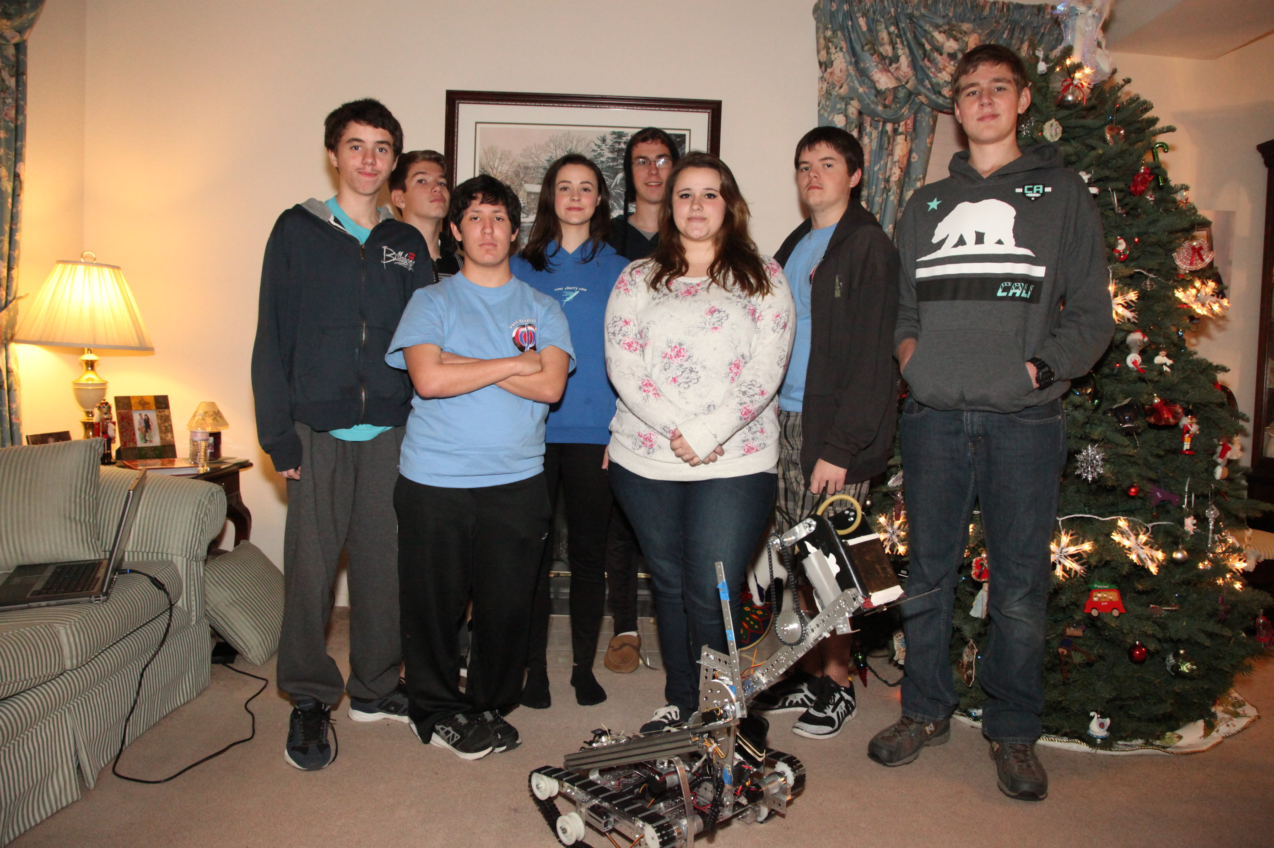

**Powered through Higher Innovation**

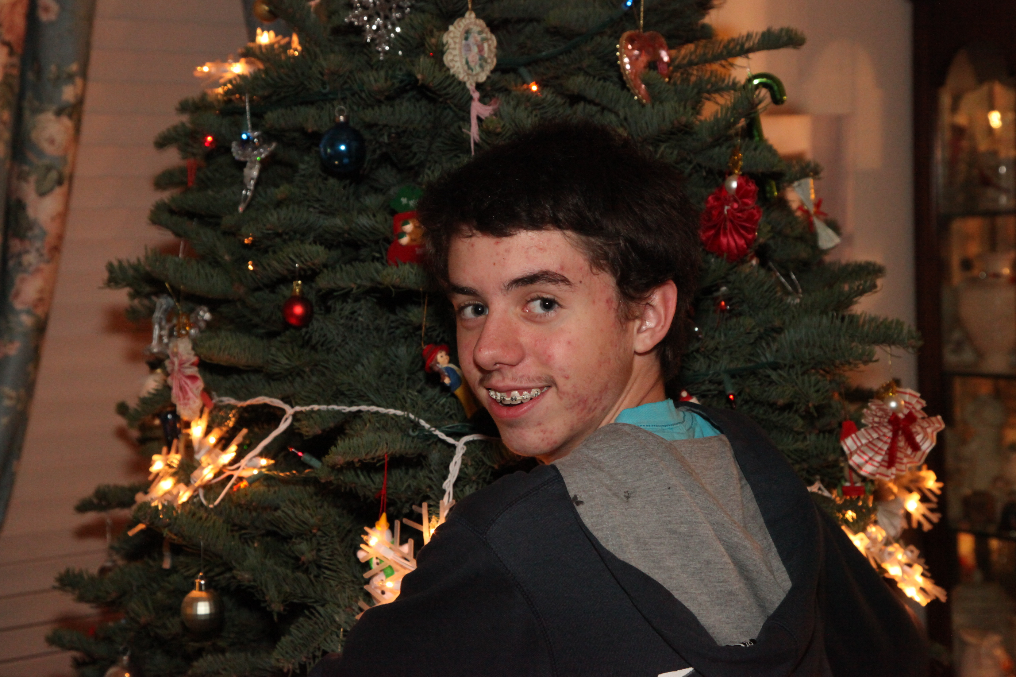

**Name:** Jeremiah Baughman

**Years on Team:** First year.

**Job on Team:** Hardware.

**Interesting Facts:** I'm from a blended family. I love playing video games. I'm learning American Sign Language (ASL). I enjoy comedy. I like videos from YouTube.

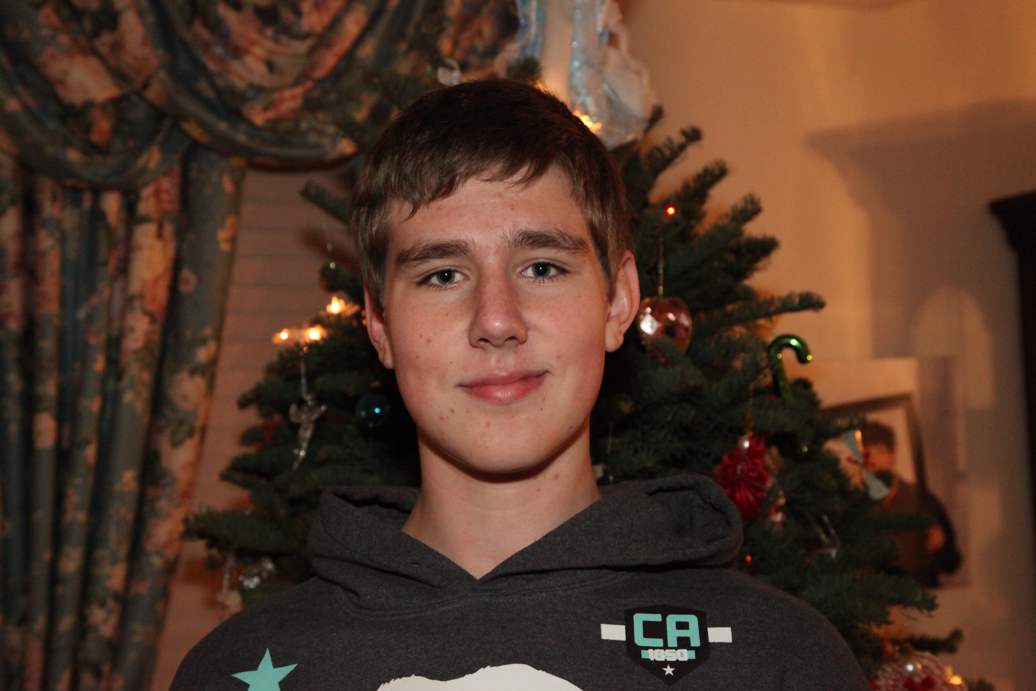

**Name:** Scott Kidman

**Years on team:** 2 years.

**Job on team:** Hardware construction and deign.

**Interesting Facts:** I am the tallest in the garage. I am good at riding a motorcycles/ dirt-bikes. I enjoy STEM and robotics.

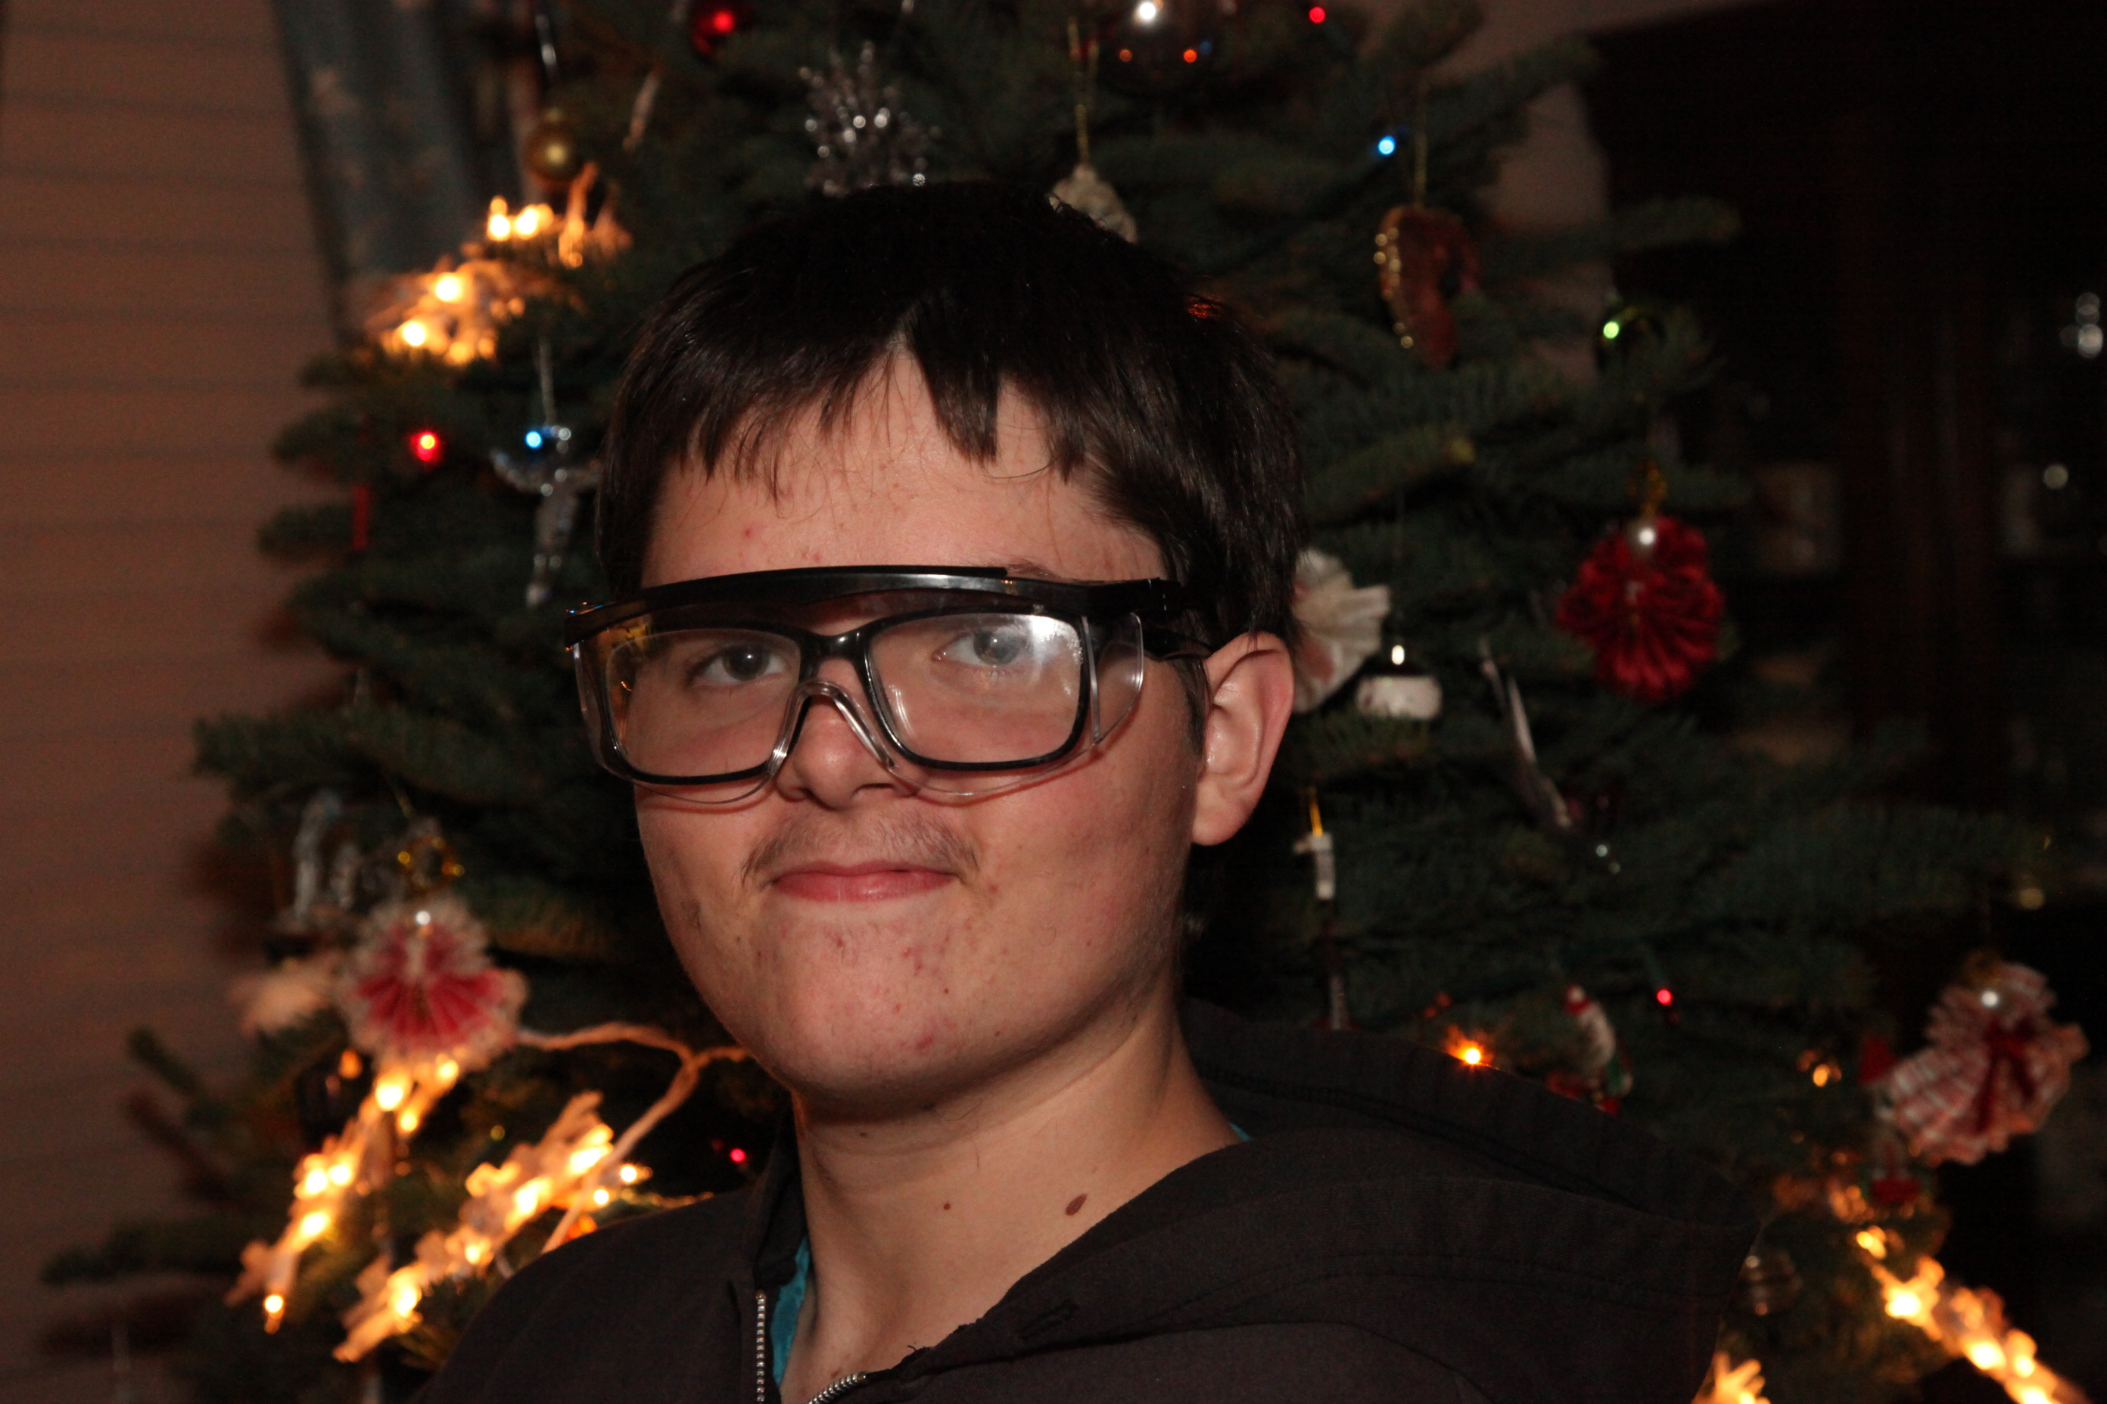

**Name:** Joe Baughman

**Years on team:** First year.

**Job on team:** Hardware and Engineering Notebook.

**Interesting Facts:** I’m learning American Sign Language (ASL). I am writing my own book. I love movies. I’m good at convocations. I’m a self-taught artiest. I’m from a blended family.

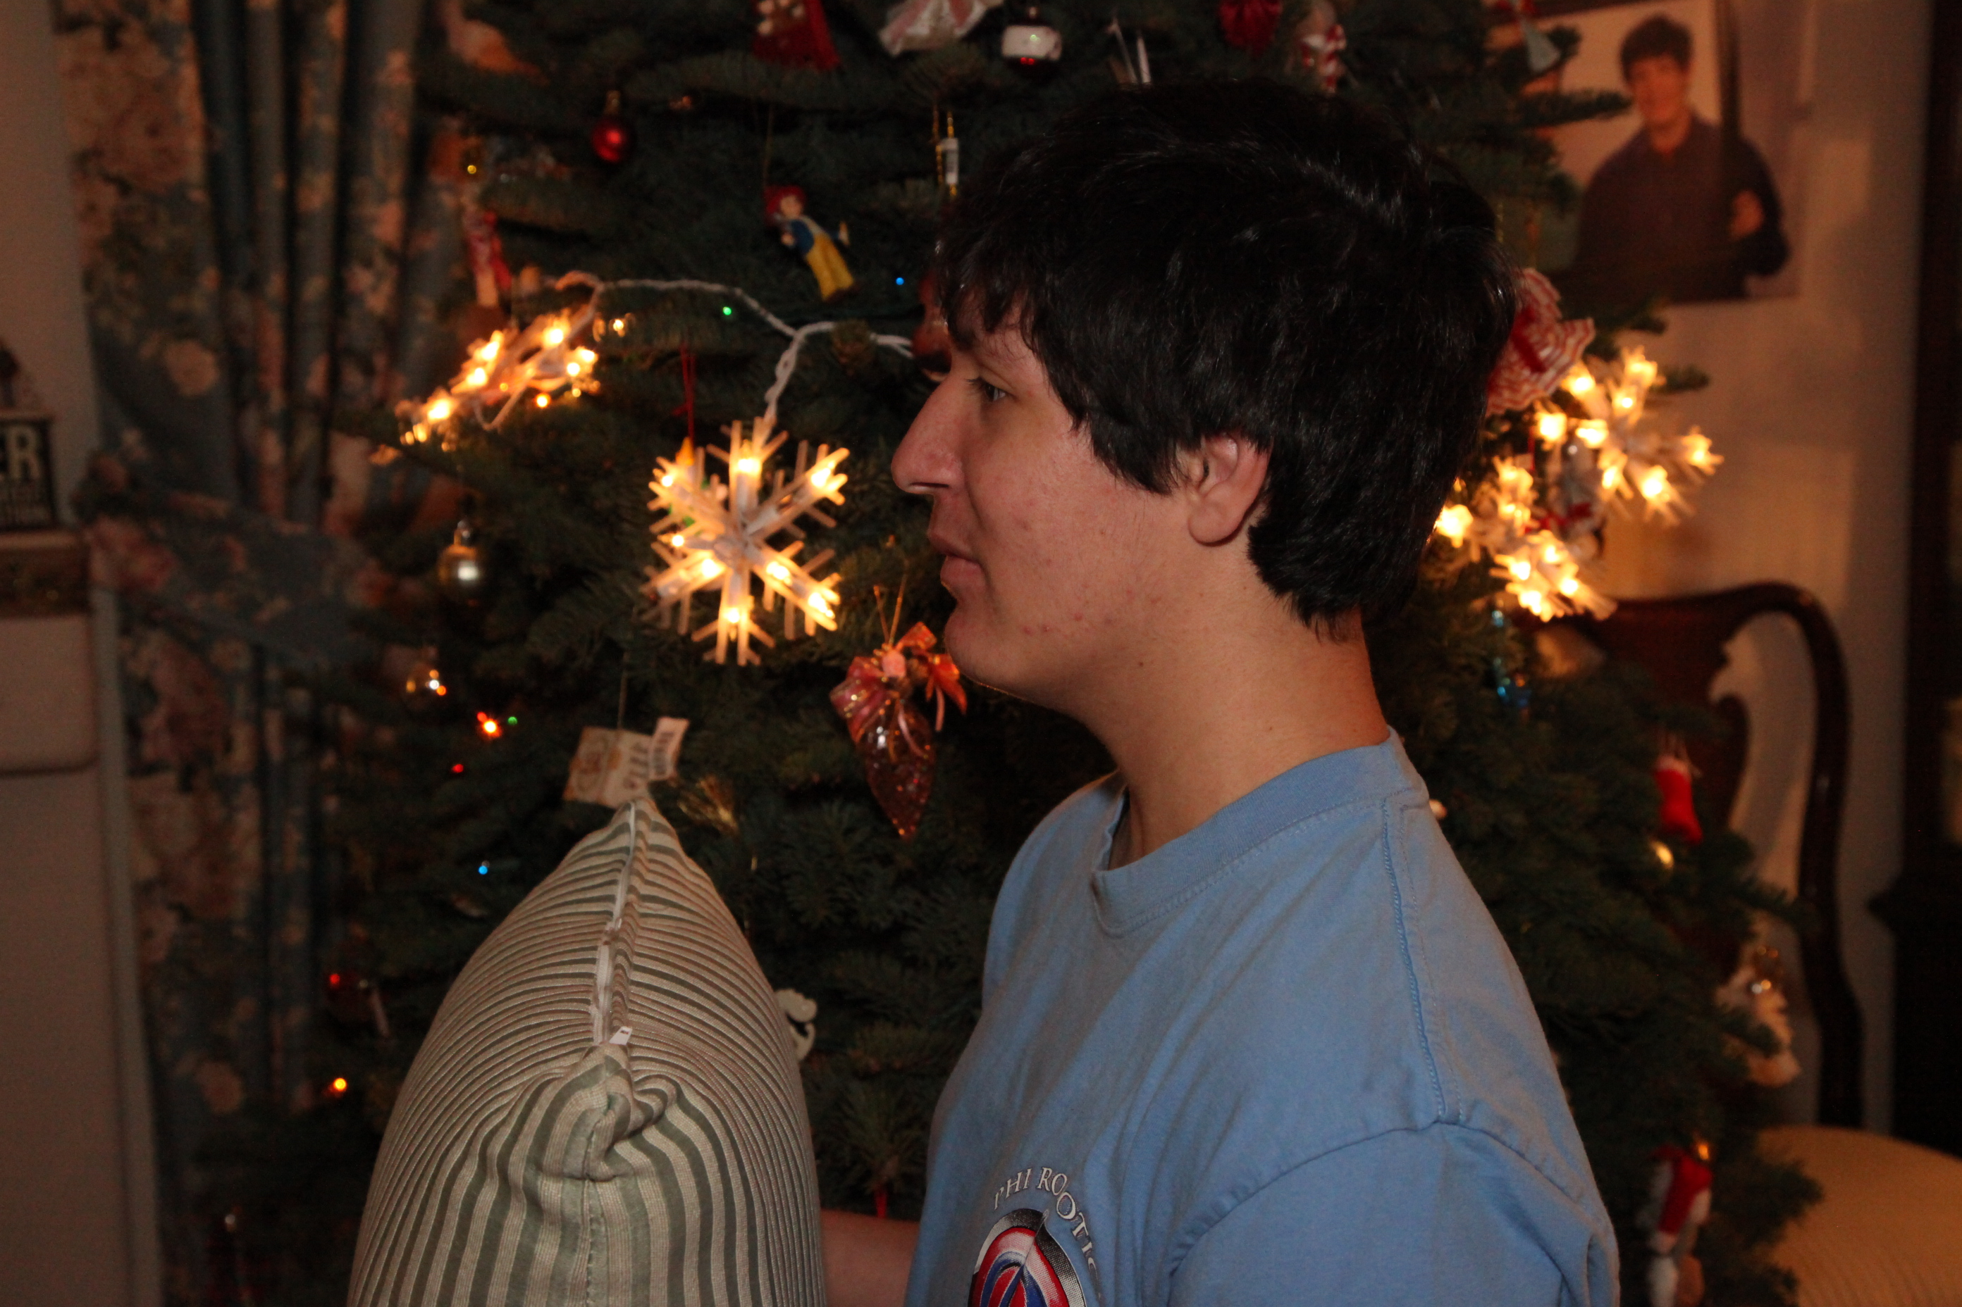

**Name:** Luke McMillan

**Years on team:** 2 years.

**Job on team:** Software.

**Interesting Facts:** I love to build weapons, I love to hunt for bones, I love monsters. I love the lord Jesus Christ. I am a HUGE Batman/ Zelda fan. And yes ladies I am SINGLE(;

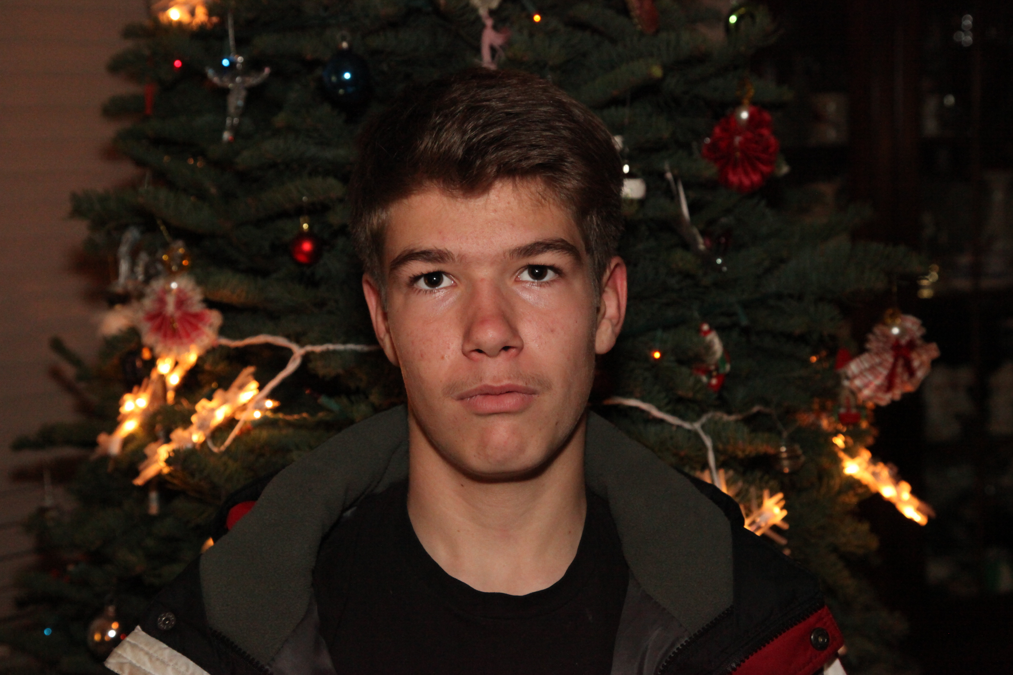

**Name:** Immanuel Lawhon

**Years on team:** 4/12 months/first year woot woot.

**Job on team:** Software (Primary), Notebook (Secondary), Hardware (Tertiary) Yep I'm Smort Laugh out loud.

**Interesting Facts:** I play hockey on my free time along with piano and other instruments. And I'm a vanilla covered chocolate bar which means I'm blonde but as smart as a brunette.

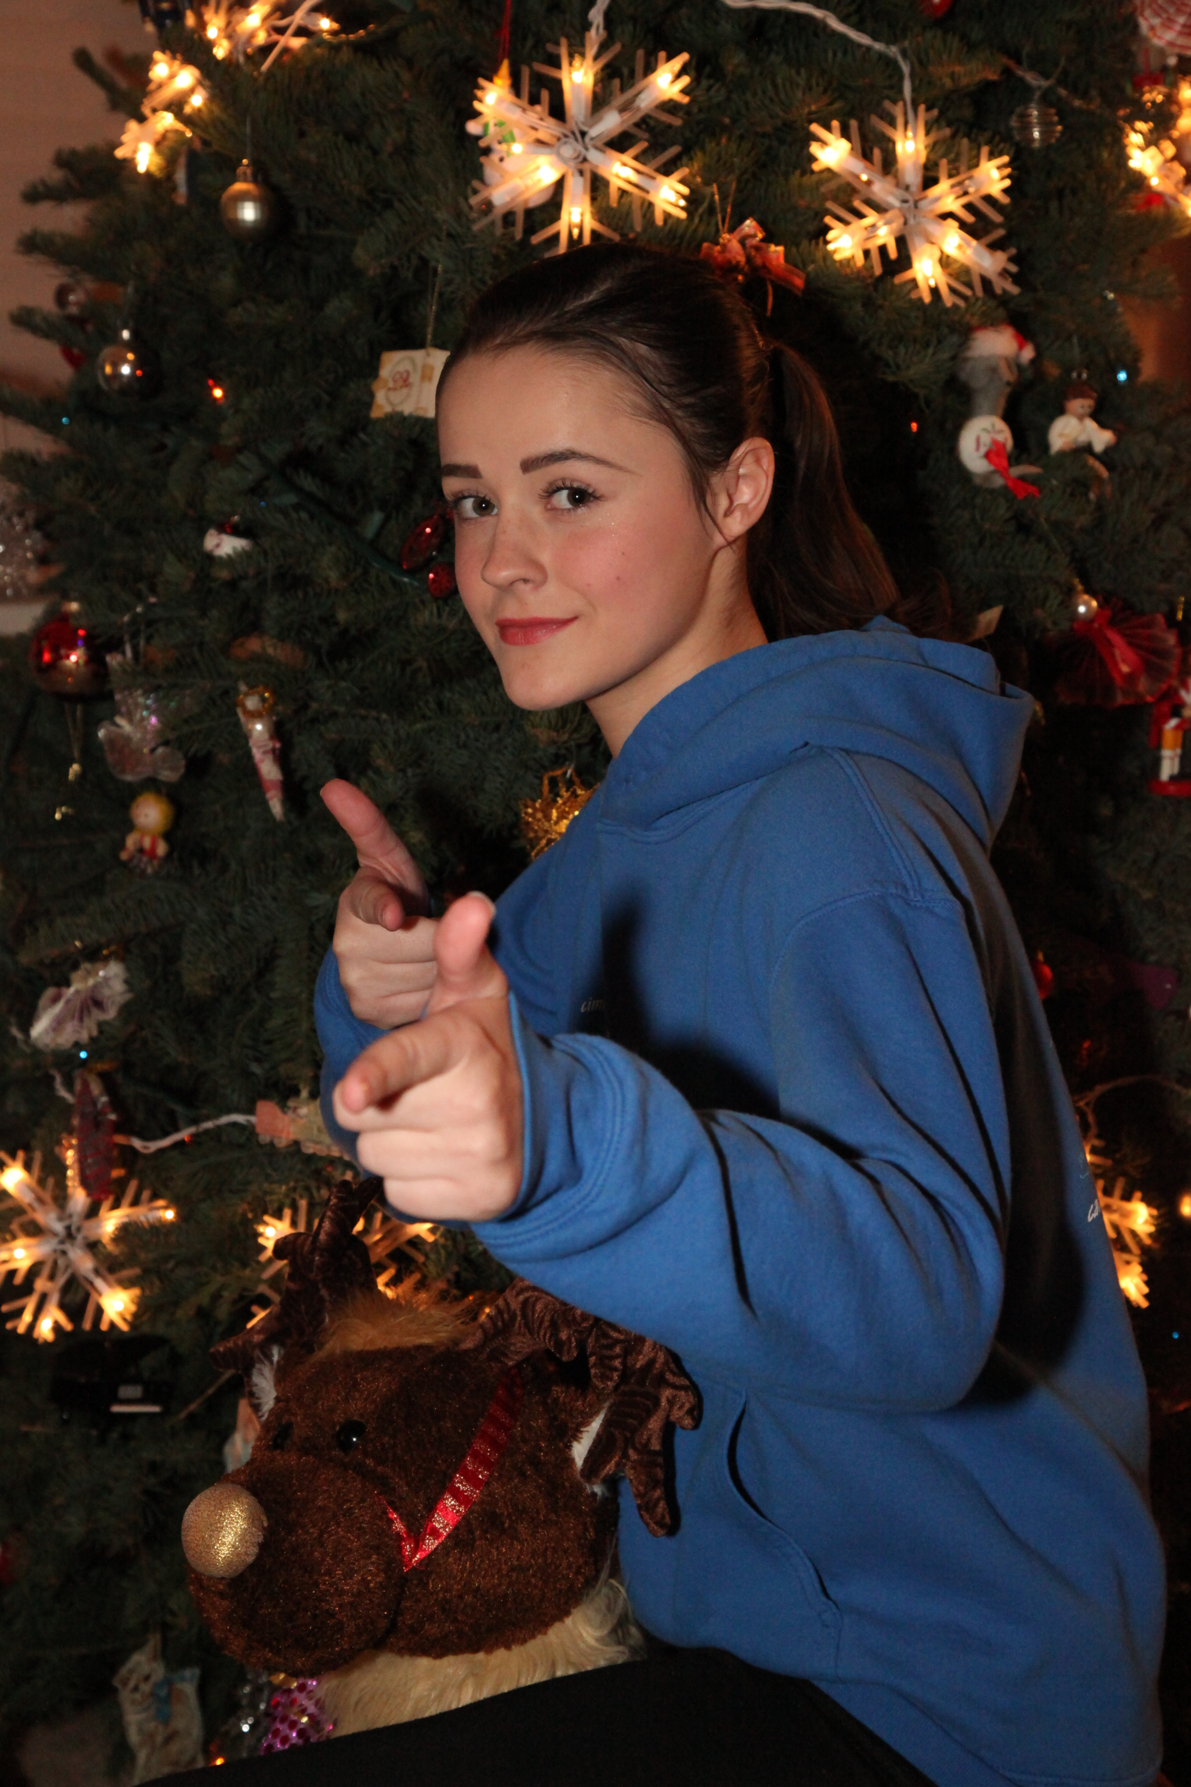

**Name:** Kayla Bachtelle

**Years on team:** Two Years.

**Job on team:** Lead Software.

**Interesting** Facts: I'm a female.

FE = iron

Male = man

Therefore I am Iron Man.

Jesus is my Savior!

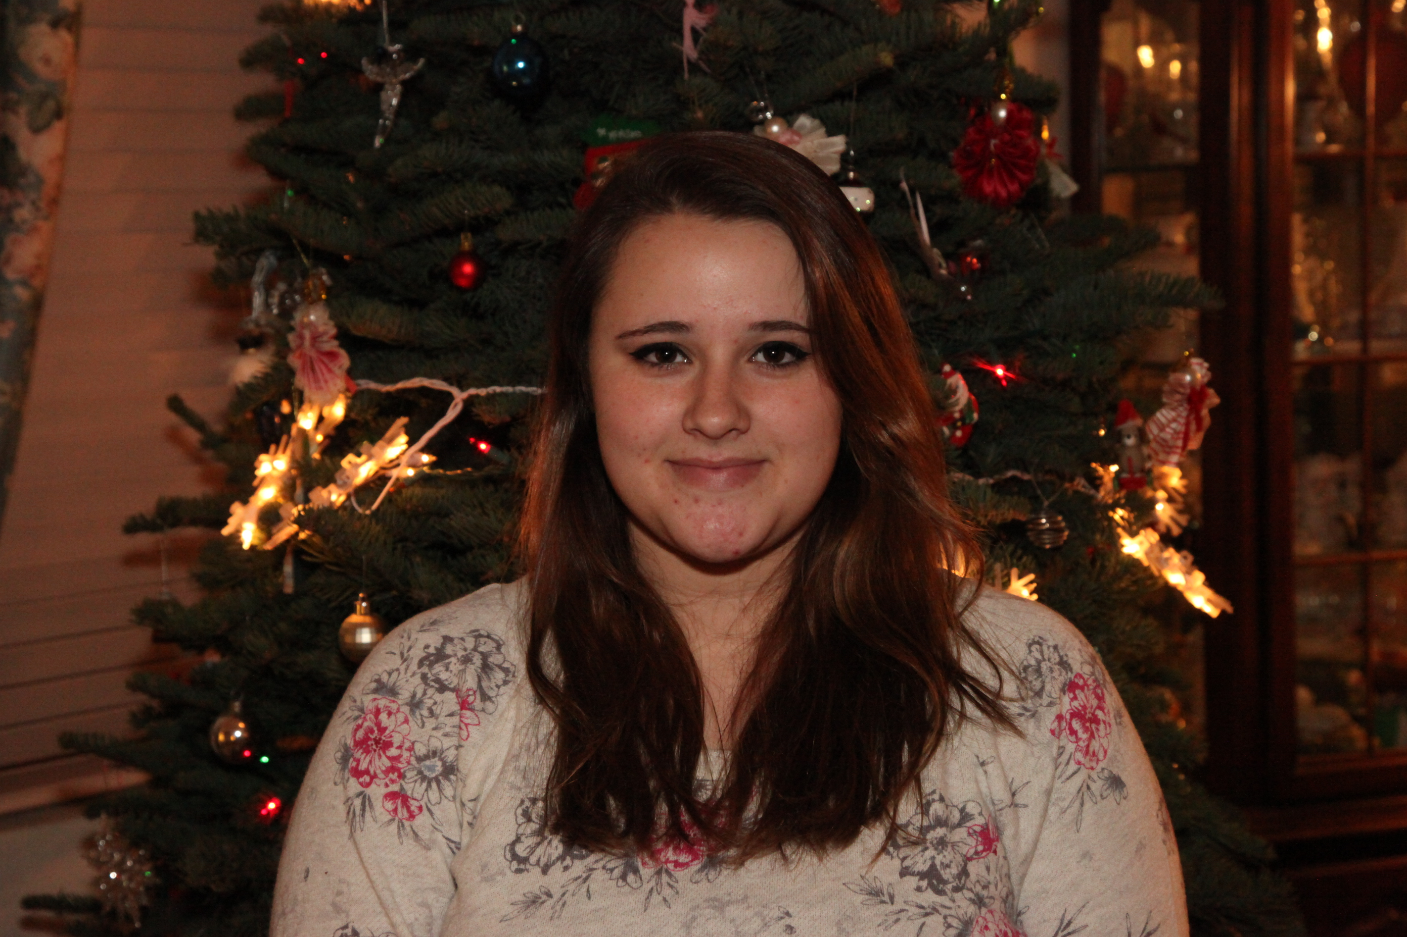

**Name:** Cierra Bachtelle

**Years on team:** 2 years.

**Job on team:** Head of notebook

# Interesting Facts: I know American sign Lagrange (ASL). Jesus Christ is my rock/savior I love people. I'm the weirdest person EVERRR!!!! NO I'm older then my sister Kayla!!!!!!! Whats up baby cakes? LOL. I LOVES TO CUDDLE!!!!!! I LOVE CHOCOLATE<3.

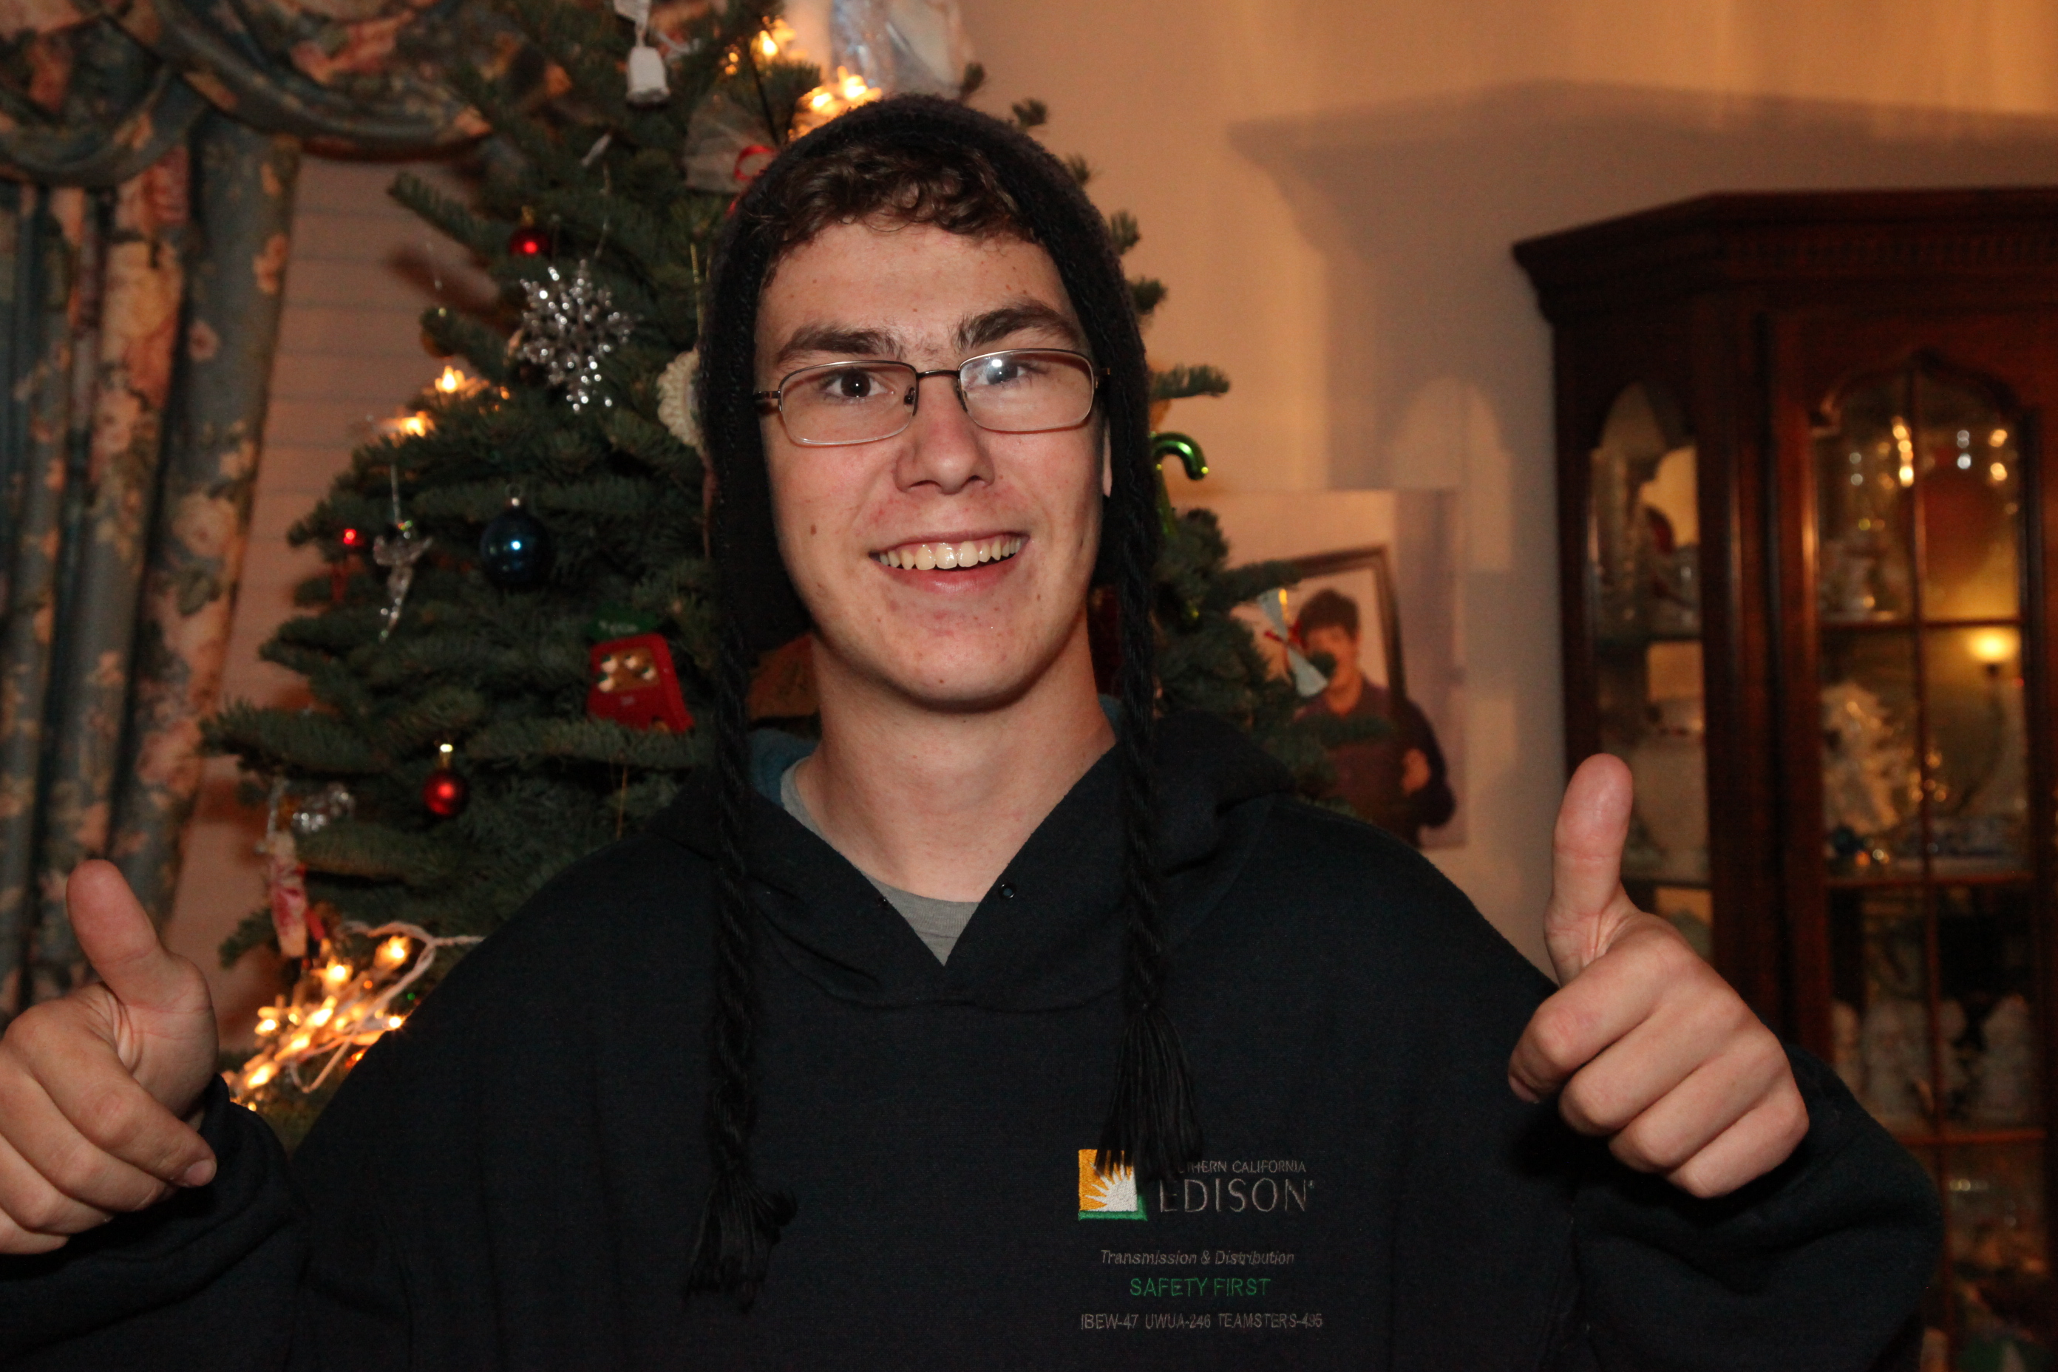

**Name:** Tim Bloot

**Years on team:** 3 years on the team, 4 years involved in First Tech Challenge

**Job on team:** Team Captain and organizer.

**Interesting Facts:** I am Dutch, Oranje for life! I am an I.T. intern at my school, and have been on a team that sent an experiment to the International Space Station. My hobbies include building computers, sailing, and ATV riding. Lockheed is my dream company, and I love the cold.

**OUR COACH!**

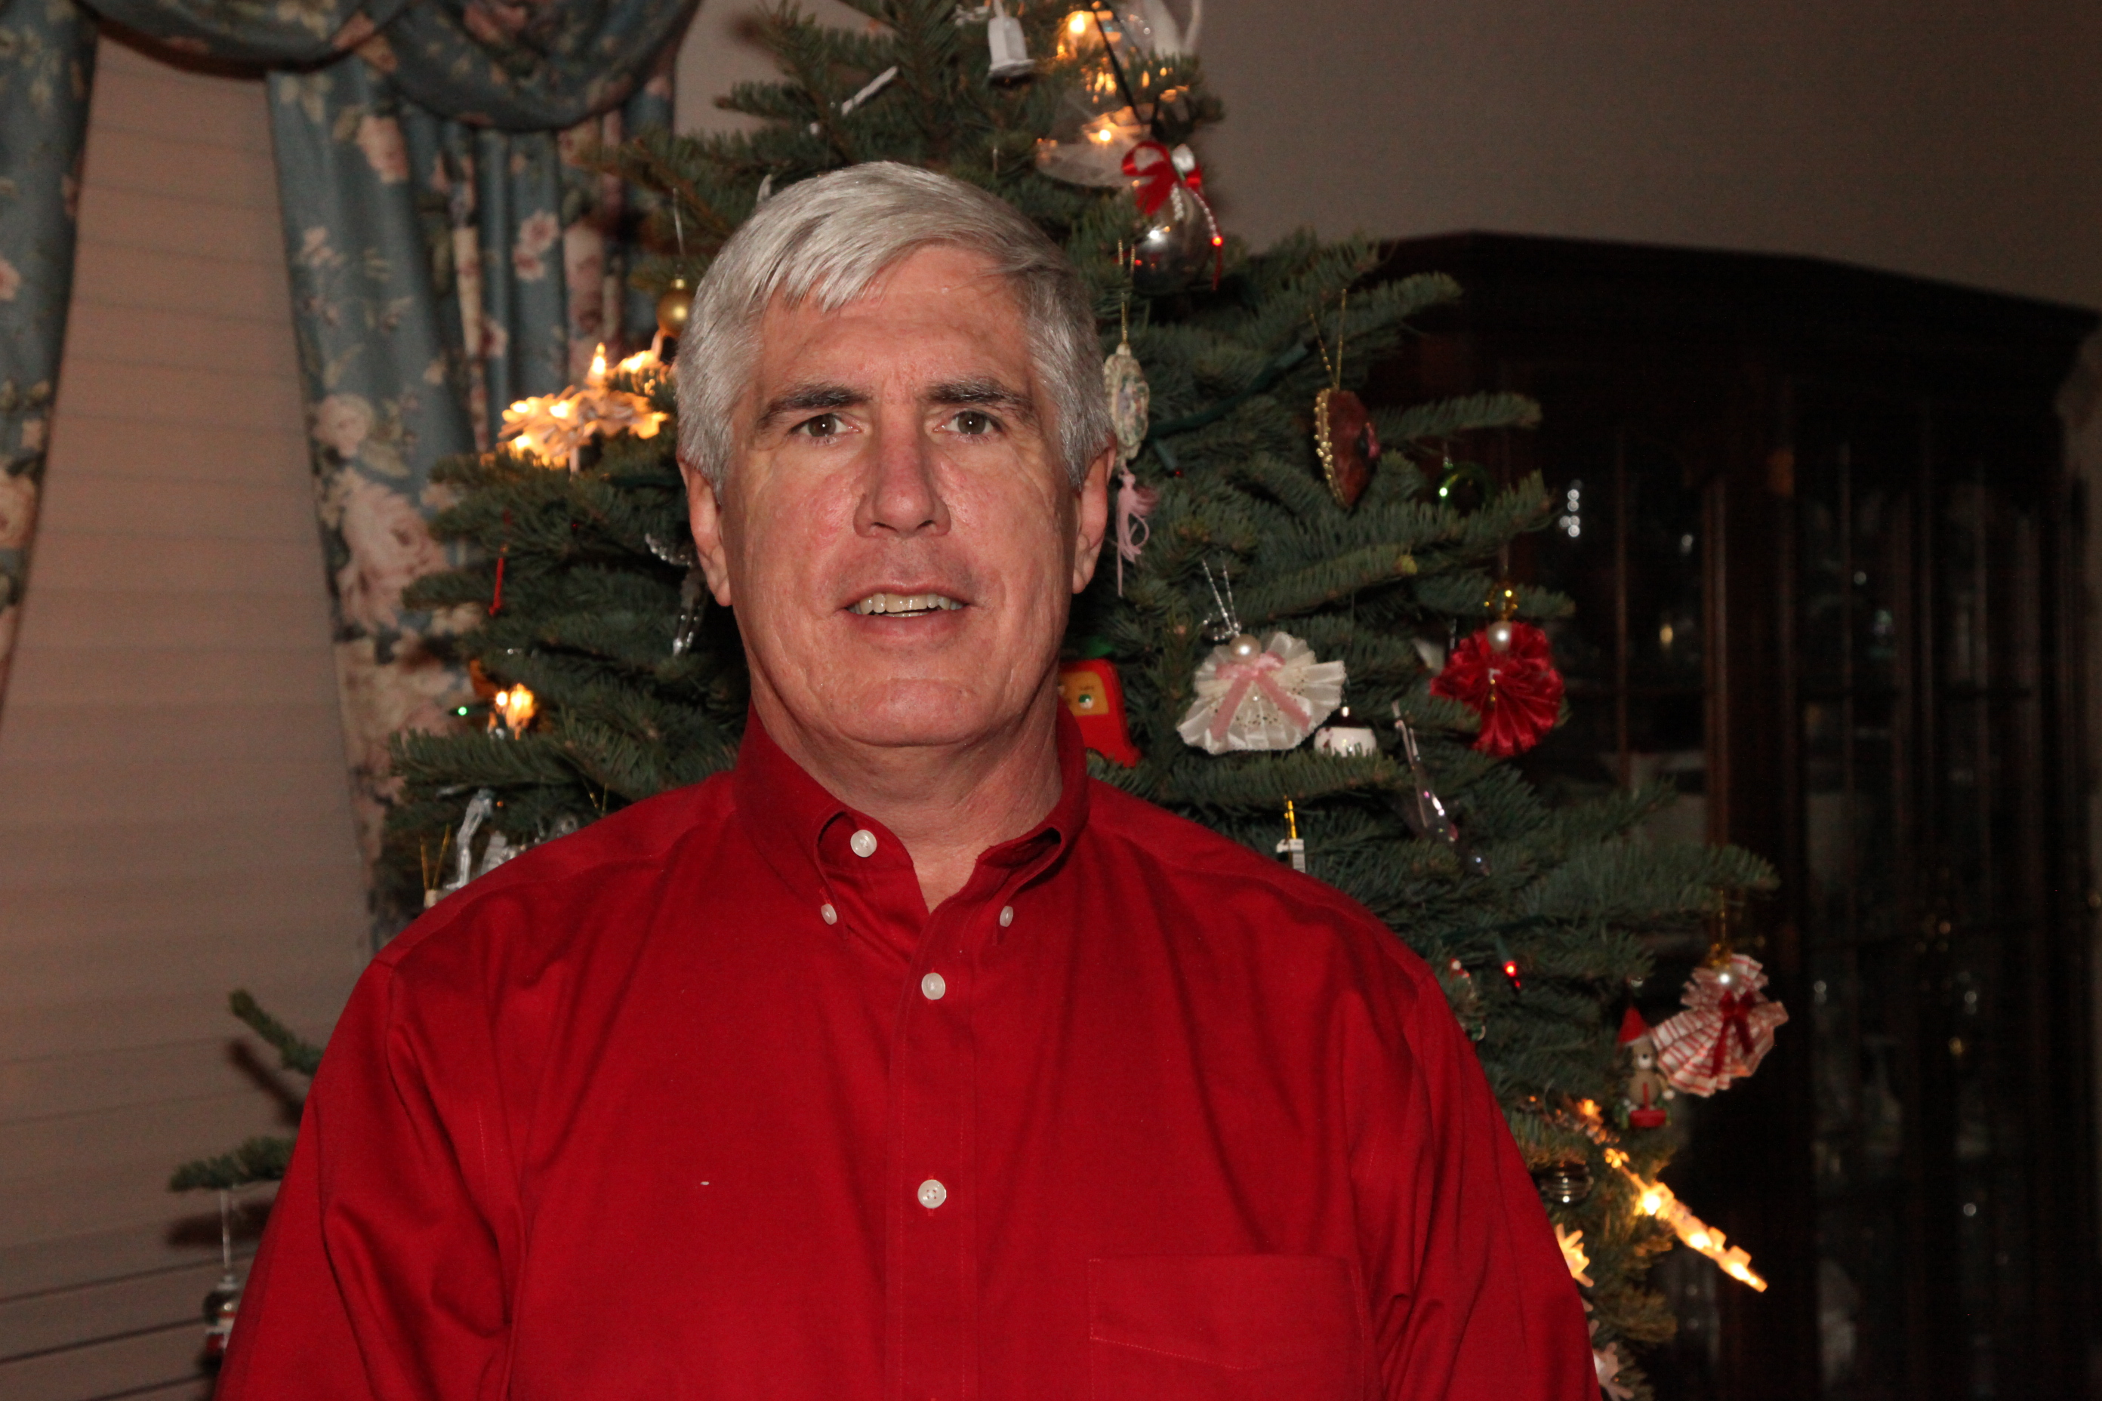

**Name:** Mike McMillan

**Job:** Senior Manager for Lockheed Martin's Advanced Development Projects group, also known as “The Skunk Works”

**Intrusting Facts:** Mr. McMillan has coached FIRST robotics teams for eight years, including FLL and FTC teams. He has spent a total of 13 months bicycling in various parts of the world. His trips have taken him across the United States, (where he dipped his back wheel in the pacific and front wheel in the Atlantic), Europe (from the Mediterranean coast off Turkey to two hundred kilometers north of the Arctic Circle), India and Nepal.

**TEAM MENTORS**

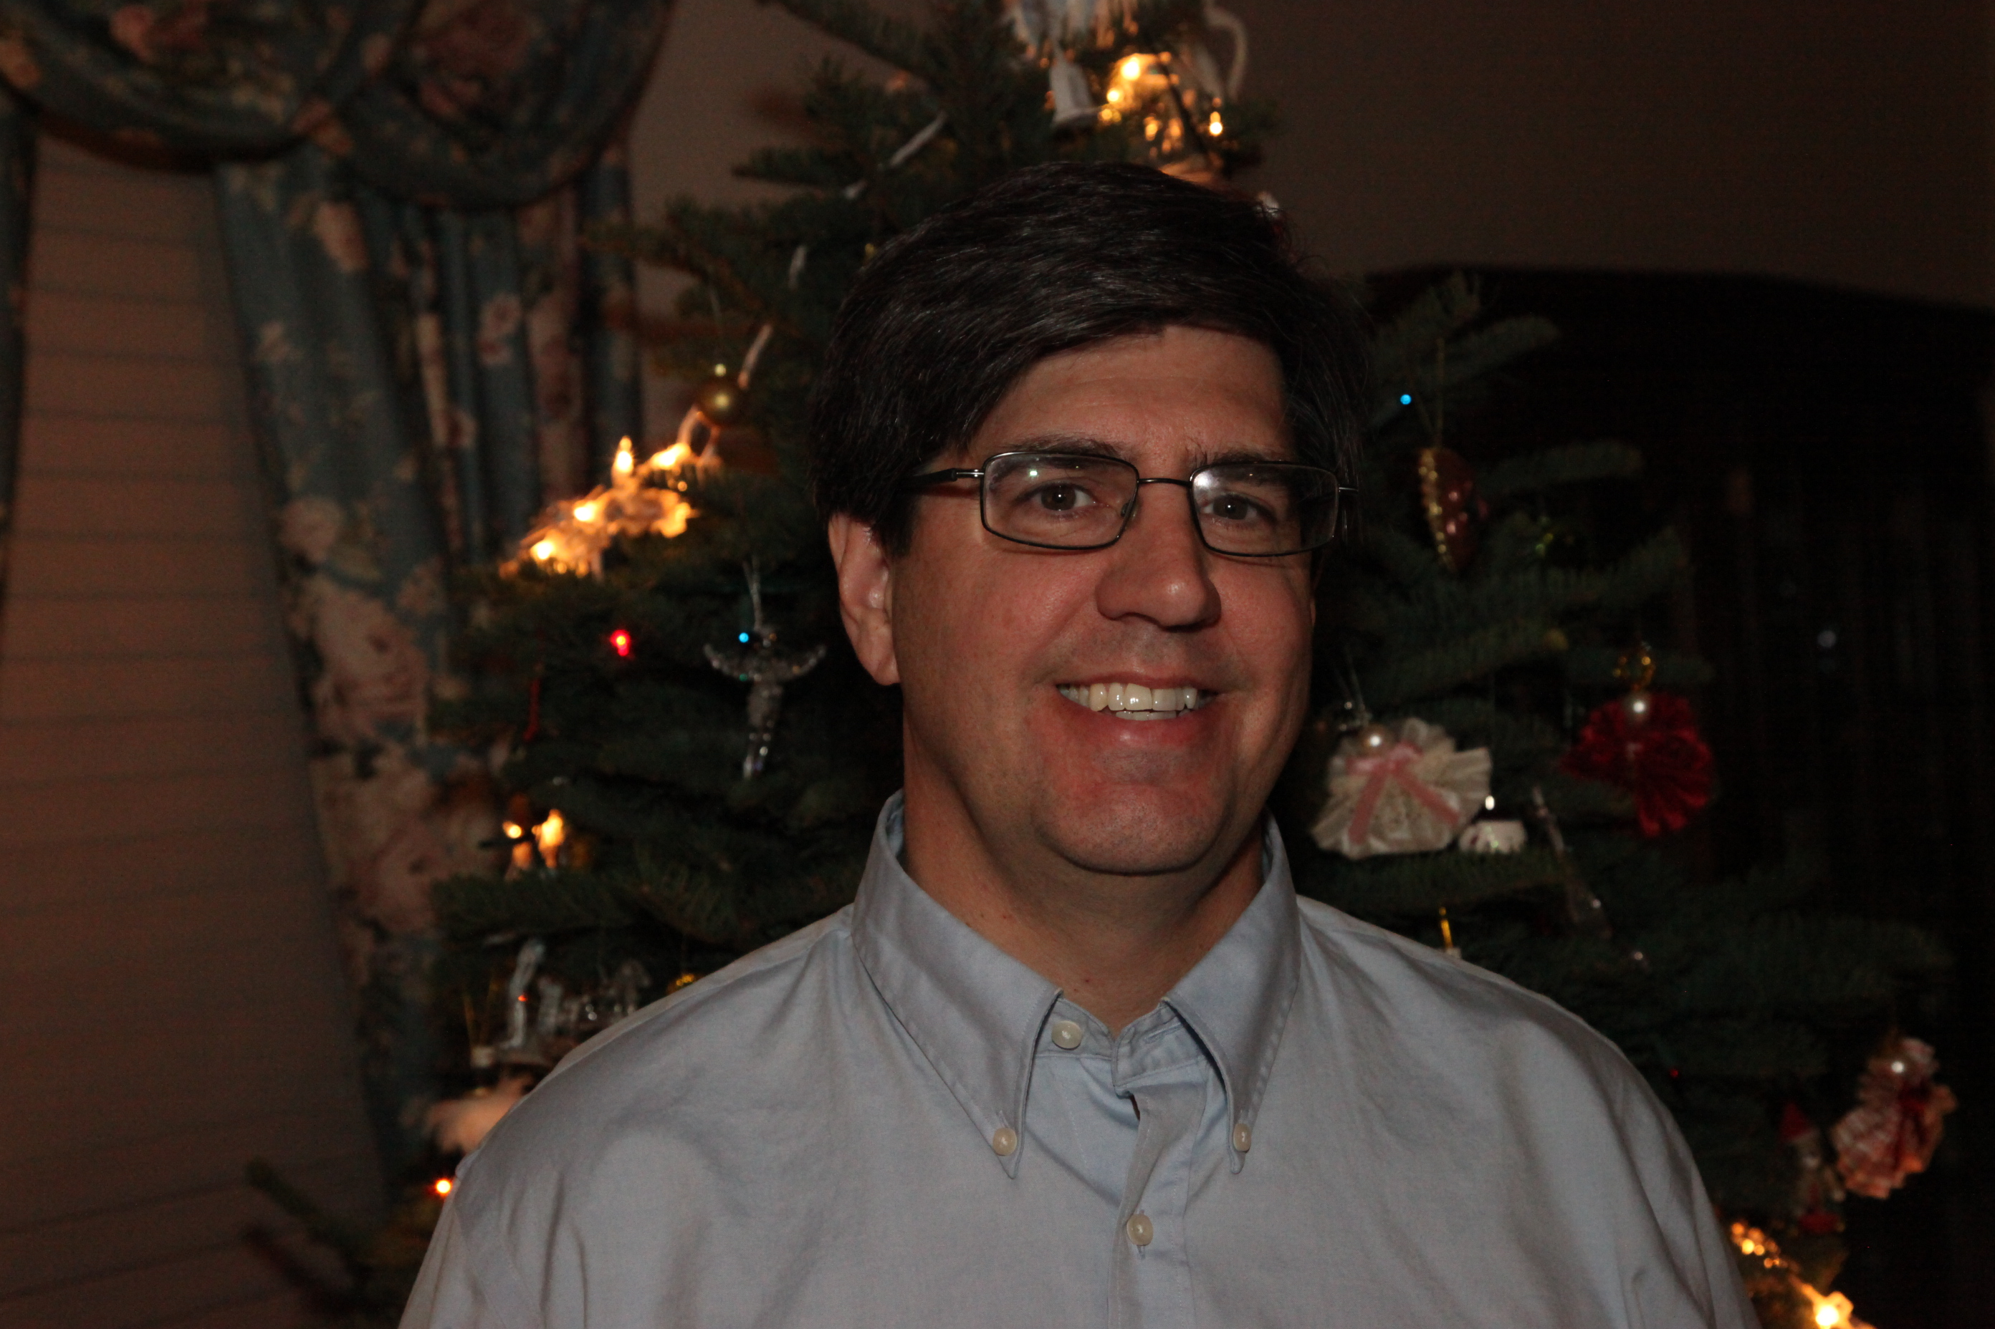

**Name:** Daniel McLeod

**Job:** Leads a team of software engineers in provide applications for real time and post flight data analysis. In addition, the team provides software solutions for the flight test cards, mission planning, and test result reporting.

**Interesting Facts:** Through his career, Daniel has worked on real time control systems all over the world for rail and ground transportation. Daniel has worked on systems in China, South Korea, Singapore, Taiwan, London, Toronto, Atlanta, Washington D.C., and Los Angeles. Daniel enjoys playing ice hockey with his sons, skating with his daughters and playing many different puzzle video games with them all.

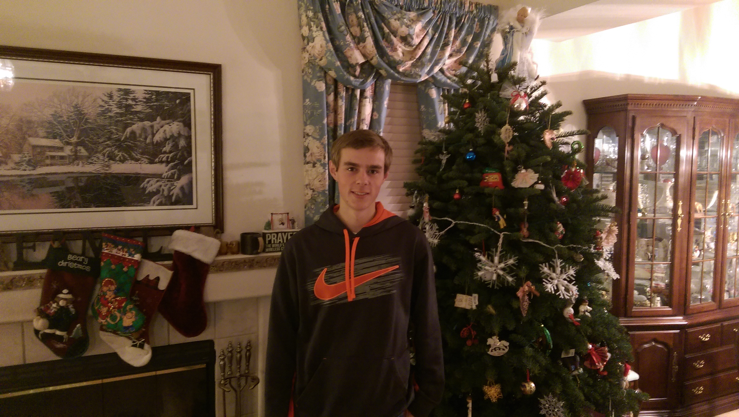

**Name:** Michael Kidman

**Job:** Full time college student (or so you thought)

**Intrusting Facts:** By day he is an ordinary college student. But by night he becomes a FTC mentor. Who using his super abilities of years of experience on robotics teams, to guide and inspire a pack of miss matched teens into a team.